TECHNOLOGY TUTORIAL - INTRODUCTION
Photonic crystal fibers (PCFs) were first demonstrated in 1996 and have generated much attention since then. PCFs are optical fibers that employ a microstructured arrangement of low-index material in a background material of higher refractive index. The background material is often undoped silica and the low index region is typically provided by air voids running along the length of the fiber.
PCFs may be divided into two categories, high index guiding fibers and low index guiding fibers. Similar to conventional fibers, high index guiding fibers are guiding light in a solid core by the Modified Total Internal Reflection (M-TIR) principle. The total internal reflection is caused by the lower effective index in the microstructured air-filled region.
Low index guiding fibers guide light by the photonic bandgap (PBG) effect. The light is confined to the low index core as the PBG effect makes propagation in the microstructured cladding region impossible.
The strong wavelength dependency of the effective refractive index and the inherently large design flexibility of the PCFs allow for a whole new range of novel properties. Such properties include endlessly single-moded fibers, extremely nonlinear fibers and fibers with anomalous dispersion in the visible wavelength region.

TUTORIAL - HIGH INDEX GUIDING FIBERS
M-TIR is analogous to total internal reflection known from standard optical fibers. It relies on a high index core region, typically pure silica, surrounded by a lower effective index provided by the microstructured region. The effective index of such a fiber can, in the simple case, be approximated by a standard step index fiber, with a high index core and a low index cladding. However, the refractive index of the microstructured cladding in PCFs exhibits a wavelength dependency very different from pure silica - an effect which allows PCFs to be designed with a complete new set of properties not possible with standard technology. As an example, the strong wavelength dependence of the refractive index allows design of endlessly single-moded fibers, where only a single mode is supported regardless of optical wavelength. Furthermore, it is possible to alter the dispersion properties of the fibers, thereby making it possible to design fibers with an anomalous dispersion at visible wavelengths.
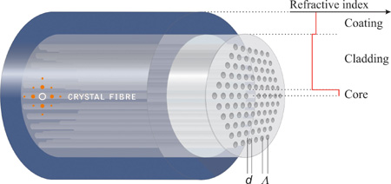
More complex index structures can also be constructed by utilizing arrangements of holes of different size in various periodic or nonperiodic structures. In addition, highly asymmetric core fibers can be fabricated thereby creating fibers with very high level of birefringence.
The technology also makes it possible to create highly nonlinear fibers which can be used for e.g. super continuum generation.

TUTORIAL - THE BANDGAP EFFECT
Photonic bandgap fibers are based on physical mechanisms fundamentally different from the M-TIR guiding fibers. The bandgap effect can be found in nature, where the beautiful and bright colors that are seen in butterfly wings are the result of naturally occurring periodic microstructures. The SEM picture at the bottom shows the microstructure on a butterfly wing. The structure size is in the order of a few microns.

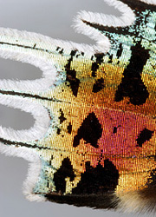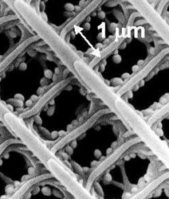
The periodic microstructure in the butterfly wing as well as in PBG fibers results in a so called photonic bandgab, where light in certain wavelength regions cannot propagate. In the butterfly wing this light is reflected back, and is seen as the bright colors. In a PBG fiber, the core is created by introducing a defect in the PBG structure (e.g. an extra air hole), thereby creating an area where the light can propagate. As the light can only propagate at the defect region, a low index guiding core has been created. This is not possible in standard fibers, and the low index guiding of PBG fibers therefore opens a whole new set of possibilities. In this way, it is possible to guide light in air, vacuum or any gas compatible with the fiber material.

TECHNOLOGY - AIR GUIDING FIBERS
A special class of PBG guiding fibers is the air-guiding fibers, where the field is confined to an air-filled core. Like other PBG fibers, air-core fibers only guide light in a limited spectral region. For fibers guiding around 1550nm, a typical bandwidth is ~200nm. Outside this region, the fiber core is anti-guiding.
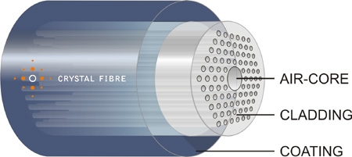
Guiding light in a hollow core holds many promising applications like high power delivery without the risk of fiber damage, gas sensors or extreme low loss guidance in vacuum.
Furthermore, this class of fiber has other spectacular properties not found in any other fiber type. They are almost insensitive to bending (even at very small bending radii) and extreme dispersion properties, such as anomalous dispersion values in the thousands of ps/nm/km regime is easily obtained. Due to a negligible contribution from the core material (air), the total dispersion of PBG fibers is to a high degree dominated by waveguide dispersion.

TECHNOLOGY - FABRICATION
Fabrication of PCF, like in conventional fiber fabrication, starts with a fiber preform. PCF preforms are formed by stacking a number of capillary silica tubes and rods to form the desired air/silica structure.
This way of creating the preform allows a high level of design flexibility as both the core size and shape as well as the index profile throughout the cladding region can be controlled. This is very useful for fabrication of e.g. polarization maintaining fibers with highly asymmetric core regions, where multiple of the capillary tubes are replaced with solid silica rods.
When the desired preform has been constructed, it is drawn to a fiber in a conventional high-temperature drawing tower and hair-thin photonic crystal fibers are readily produced in kilometer lengths. Through careful process control, the air holes retain their arrangement all through the drawing process and even fibers with very complex designs and high air filling fraction can be produced.
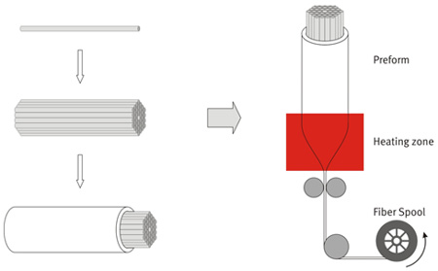
Finally, the fibers are coated to provide a protective standard jacket that allows robust handling of the fibers. The final fibers are comparable to standard fiber in both robustness and physical dimensions and can be both striped and cleaved using standard tools.

